

**Mawlana Bhashani Science and Technology University**

**Project Report**

Course Code: ICT-3106

Course Title: Software development Project-II

Project Report On: Medicine Shop Product Management System

Date of Submission: 22/12/2021

**Submitted To Supervised By**

|  |  |
| --- | --- |
| Name: Ali Ashadullah Arif  ID: IT-18031  3rd year 1st semester  Session: 2017-2018  Dept. of ICT  MBSTU. | Dr. Sajjad Waheed  Professor  Dept. Of ICT  MBSTU |

**Chapter 1: Introduction**

* 1. **Introduction:**

Medicine Shop Product Management System is a software developed project for regularly product selling and purchasing in each customers and sellers. It facilitates to access the purchasing and selling information of a particular customer or seller in a particular product. The product information is stored by the customer and seller respectively. This will also help in evaluating the exact information eligibility criteria of this shop.

As for system development and implementation is concerned, it should help customers and sellers in managing their products purchasing and selling information systematically. The system must have a database that contains a customer or seller information and it must help the seller and customer to manipulate data, update the database, alert the admin as and when needed.

* 1. **Background**

Product management of any medicine shop can be used for finding actual number of product that is stored in this shop. It is usually verified how many products are selling and purchasing everyday with each product and category. Every day we check that how number of medicines is date expired. It also gets profit of each day. It shows for each seller’s information with his selling product with category. At last its show product categories, today sales cash, expired products and system users. That is the main accounted information for every medicine shop. That’s all for admin side. and it has another side that is for user , it shows only main terms of admin side such as today sale cash, product categories, expired products and system users.

* 1. **Objective**

The aim of the project is accounted all information of a medicine shop in a table or chart.

This is to be achieved by the following objectives:

1. To carry out the analysis of up-down profit or sell of this shop.
2. To design a new system for shop management system with added some new idea.
3. To implement the design using laravel.
4. To develop shop management system based on expire date.
5. To acquire the all information of each sellers and customers.
   1. **Methodology**
      * Some phases of projects as follows :

* **Planning :** This part is the initiation part where the research study was started. In planning, we start in searching where we conduct ourstudy. We plan on how to collect data and how to organize our time in conducting a research interview. Organized the members of their individual roles and obligations in conducting the study. In planning, it includes analyzing, designing, software development, testing, and implementation.
* **Project Scope :** The project consists of software part. The installation for the software like vs code, xammp and Microsoft access is needed for the project in order to achieve the goals.
* **Development of methodology :**The actual methodology is developed in this phase. Detailed descriptions of each task in the methodology are documented , including the objectives, inputs, approach, relevant models, applicable tools and techniques, outputs and any references.

**Chapter 2: System concept and analysis**

**2.1 System functional requirements**

It is important because to make sure the system meet their requirement and to

perform better phase of system under making.

The scopes are:

* This system will focus on total sells on a particular day.
* Total sell depends on products that’s sold in every day.

**Manager/Admin**

* To manage and take the exact information.
* To show the users information and remove the users for bed behaving.
* To view the users sell and purchase product-wise, date wise and name wise

**Users/Customers**

* To insert the product that he purchases and that store he’s account.
* To view their product purchase report by product-wise and name-wise.

**2.2 Technology**

* **Programming languages**
* Frontend
* Bootstrap
* CSS
* Backend
* Laravel
* Database
* MySQL
* **Framework**
* Frontend
* Laravel
* Bootstrap
* Backend
* laravel
* **Development tools**
* Editor
* Visual studio code
* Textpad
* Server
* Xampp
* **Bootstrap**

Bootstrap is a free and open-source CSS framework directed at responsive, mobile-first front-end web development. It contains CSS- and (optionally) JavaScript-based design templates for typography, forms, buttons, navigation, and other interface components.

* **CSS**

Cascading Style Sheets (CSS) is a style sheet language used for describing the presentation of a document written in a markup language such as HTML. CSS is a cornerstone technology of the World Wide Web, alongside HTML and JavaScript.

* **MySql**

MySQL is**an open-source relational database management system (RDBMS).It** is a**relational database management system (RDBMS) developed by Oracle that is based on structured query language (SQL).** A database is a structured collection of data. It may be anything from a simple shopping list to a picture gallery or a place to hold the vast amounts of information in a corporate network.

* **Laravel**

Laravel is an open-source PHP framework, which is robust and easy to understand. It follows a model-view-controller design pattern. Laravel reuses the existing components of different frameworks which helps in creating a web application.

The web application thus designed is more structured and pragmatic.

Laravel offers a rich set of functionalities which incorporates the basic features of PHP frameworks like CodeIgniter other programming languages like Ruby on Rails. Laravel has a very rich set of features which will boost the speed of web development.

If you are familiar with Core PHP and Advanced PHP, Laravel will make your task easier. It saves a lot time if you are planning to develop a website from scratch. Moreover, a website built in Laravel is secure and prevents several web attacks.

**Chapter 3: System Implementation**

**3.1 System implementation**

Medicine Shop Product Management System is**web based,** which can be implemented on any devices. In This application, Laravel is used for front-end and back-end and xampp is used for database.

* **Login**

In this Application, user will be able to his individual account

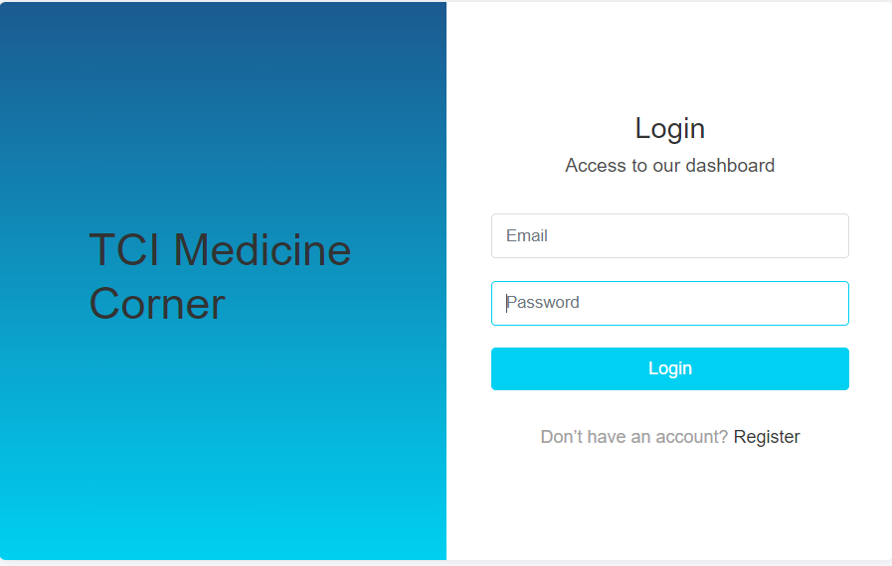

Fig : 5.1.1

Fig 5.1.1 : Click Register button if anyone new in this site, then add his/her

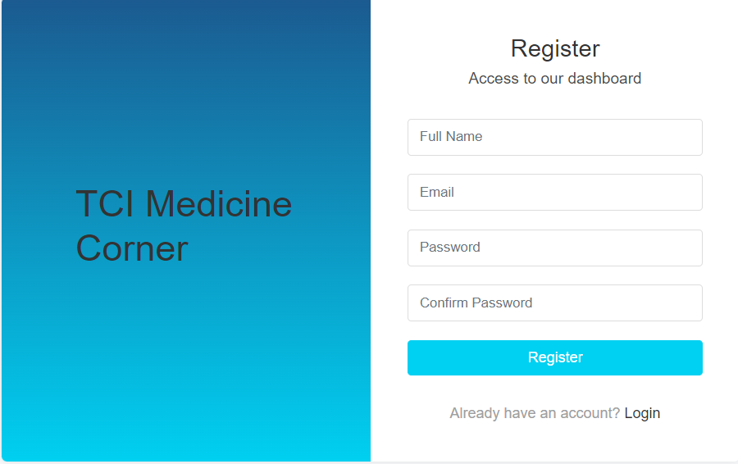

* **Home Page (User)**

After login, the application will redirect to home page and

As well as, after user’s login will shows all information such as: Today Sales cash, Product Categories, Expired Products and Sytem Users.

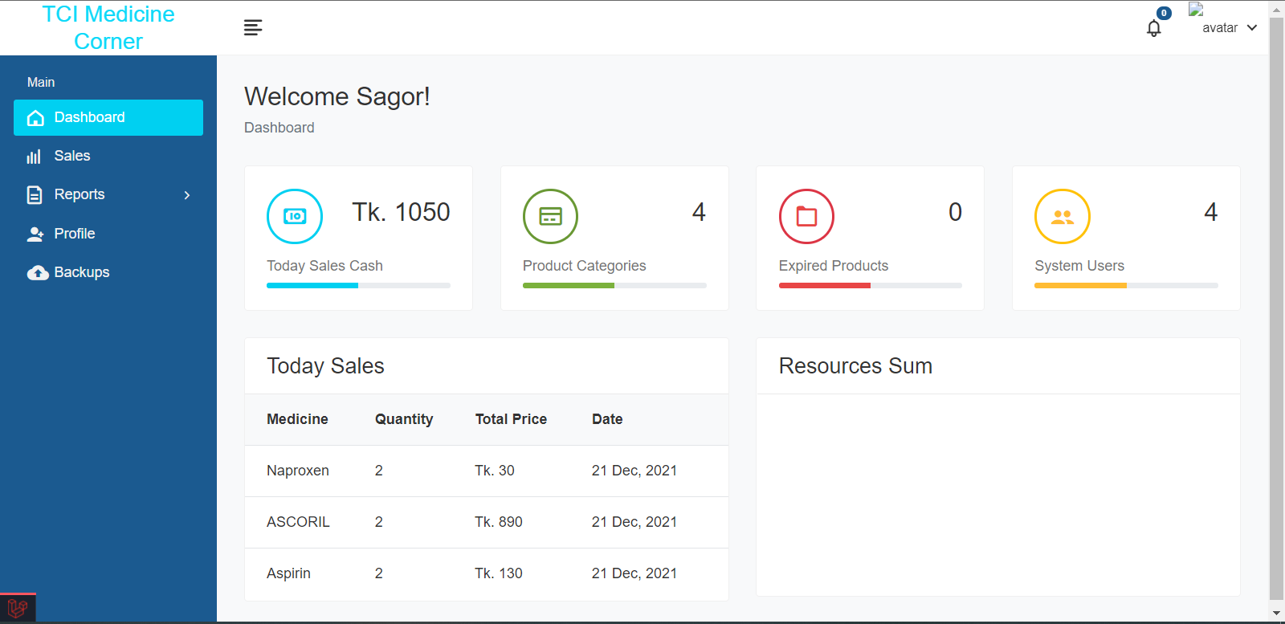

Figure 5.1.2

* **Home Page (Admin)**

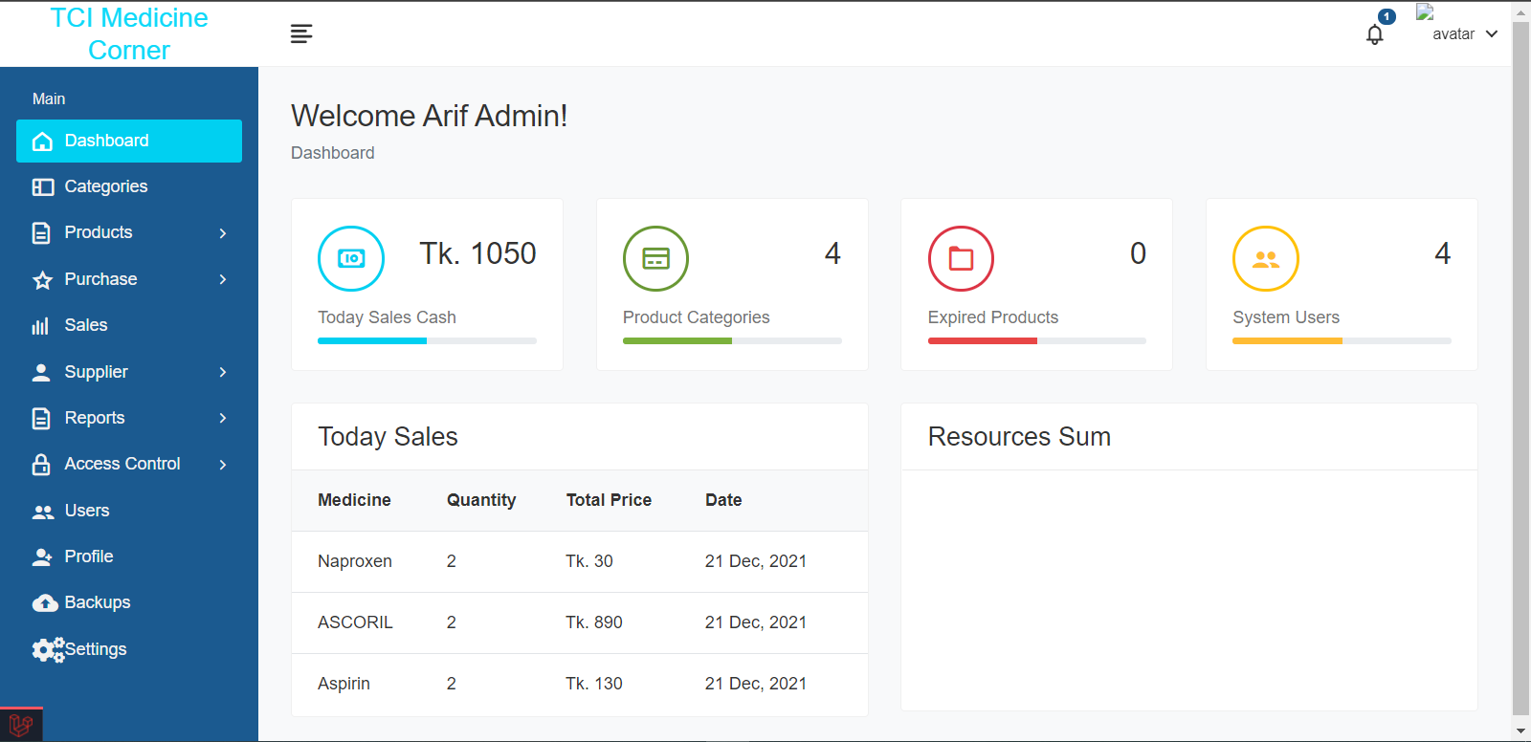

Figure 5.1.3

with all information of this management of admin login.